Instructions for Completing Timesheets for March to April 2020

In response to COVID-19, the University has implemented a different process for recording hours in the payroll system. Please use the attached timesheet to record actual hours worked AND/OR hours missed between March and April. Please ensure that you have selected the appropriate situation(s) at the top of the timesheet and entered applicable the date range(s) from the dropdown menu.

Non-Appointed Employee Self-Declaration Form

If you have been diagnosed with COVID-19 or have been required to self-isolate for any reason related to COVID-19 (eg. travel, possible exposure, etc), please complete a Non-Appointed Employee Self-Declaration form. This will help the university to track COVID-19-related absences.

Timesheet Example

Jane Smith returned to Ontario from a trip to Paris on March 8 and was required to self-isolate for 14 days. Assuming Jane usually works 6 hours per week, Jane missed 12 hours of work during her isolation period because she could not perform her work duties remotely. On March 23, she worked four hours on-site in a research lab, helping to prepare for a lab shutdown. Jane missed another 20 hours of work between March 24 and April 17 because Jane could not perform any of her duties remotely.

Jane would complete the form as follows:

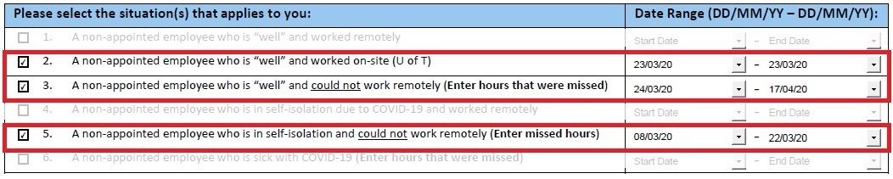

Hours Missed Due to Self-Isolation
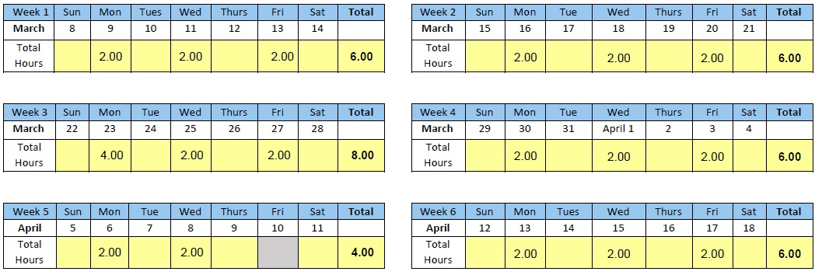
Hours Missed
“Well” and could not work remotely
Actual Hours Worked
On-Site

